Statement of Work

Grainger plc
Website Integration

Version 1.0
February 06, 2024

Contents
1 Statement of Work 3
1.1 Overview 3
1.2 Objectives 3
1.3 Delivery Approach 5
1.4 Responsibilities 7
1.5 Availability 8
1.6 References 8
2 Assumptions, Exclusions & Limitations 9
2.1 Assumptions 9
2.2 Exclusions 9
2.3 Limitations 9
3 Cost and Timelines 10
3.1 Extension of Service Period 12
4 Acceptance 14
5 Appendices 15

Statement of Work

Overview

The primary objective of this project is to develop Application Programming Interfaces (RIGHTMOVE APIs) to facilitate the seamless exchange of unit information between Salesforce and the website currently under construction by Code. Additionally, the project aims to enhance Salesforce functionality by adding or modifying fields to accommodate the new data being passed through the RIGHTMOVE APIs.

Objectives
The objectives of this project are to:
- Conduct Sprint 0 in which sufficient, detailed analysis will be conducted in order for Open Box and Grainger plc to be in a position to commence Sprint 1 development.

  - Gather and document comprehensive business requirements (OB)
  - Analysis of fields required and whether they are already in SALESFORCE.
  - Establish a high-level backlog of user stories (Prioritized based on initial business value by OB and Grainger)

  - Provide a revised forecast of the number of sprints, cost & timeline required to deliver the project.

  - Define detailed requirements and acceptance criteria (OB and Grainger)
- Deliver a solution containing the following key features:
  - Send a JSON payload to a new Grainger website API that contains details of selected, available units from Salesforce.
    - Unit details will consist of unit, building and block data/attributes including features
  - Connect to a new Unit Details API to transmit unit details for selected units from Salesforce to the website.

    - The API will pass approximately 30 unit attributes.
    - The API will pass images and documents (including floor plans, EPC, EPC graph, 360 tours) to website.

    - Enhancing
  - Salesforce Field Customization
    - We will need to add or modify approx. 12 fields in SALESFORCE to accommodate the incoming unit information.
    - Implementation of data mapping and transformation logic to align Salesforce data with the website's data structure.

- Provide an revised forecast of the number of sprints, cost & timeline required to deliver the project backlog.
- Assist Code (a third party vendor) with any technical queries regarding the standard Salesforce API to create leads.

Delivery Approach
The delivery approach will be based on the SCRUM framework. Iterative delivery is achieved through a series of 3-week sprints.
An agile delivery approach allows for the early delivery of outcomes and provides flexibility to adjust for any unforeseen opportunities or issues uncovered during the project.
A backlog will be maintained to track outcomes to be delivered and indicate priority of these outcomes relative to each other. The backlog will be a living artifact that will evolve as Open Box and Grainger plc collaborate towards maximizing the value delivered. Grainger plc stakeholders will have access to the backlog which will serve as the single source of truth with regards to scope.
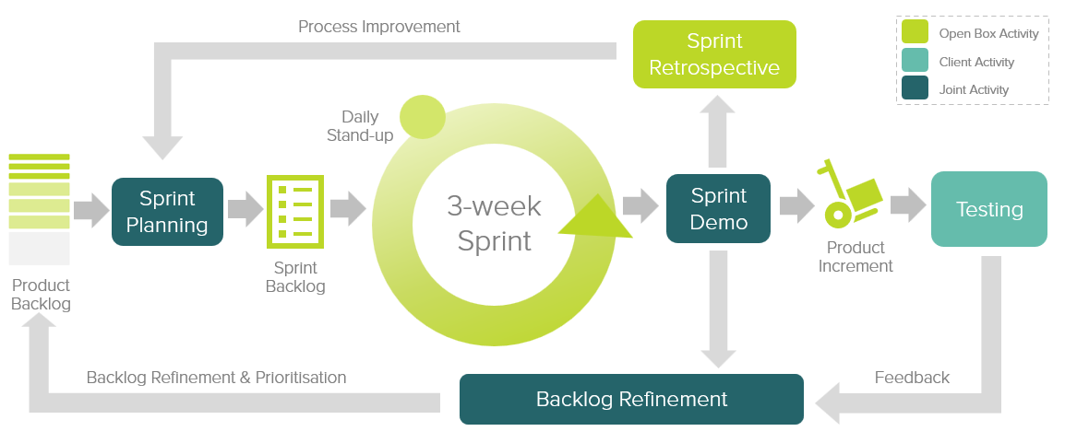

Figure 1: Agile Delivery Approach
Grainger plc representatives will be required to particulate in the following during each sprint cycle:
- Backlog Refinement – Open Box and Grainger plc representatives will meet to prioritize use stories on the backlog as well as review and agree on acceptance criteria for user stories at the top of the backlog.
- Demo – Open Box will meet with Grainger plc representatives to demonstrate the outcomes delivered in the past sprint.
- Sprint Planning – Outcomes on the backlog will be selected for the next sprint.
- Testing – Open Box will be responsible for unit testing and QA testing of all functionalities. Grainger plc representatives will conduct user acceptance testing of new functionality delivered in each sprint and provide feedback withing 1 week of the demo.
- Stand Up – Regular, 15-minute stand-up calls will be held to report on progress; the Grainger plc product owner is expected to participate in this call to provide feedback and give input on any questions that arise.
Feedback from demos and testing will be classified as either bugs or enhancements (depending on the user story and acceptance criteria). Bugs will be fixed in a subsequent sprint, whereas enhancements will be incorporated into the backlog and prioritized accordingly.
If it is expected that the critical functionality can no longer be delivered within the estimated cost and timeline, this will be communicated to Grainger plc. Grainger plc may choose to resolve this by adjusting the project scope and/or cost & timelines accordingly.

UAT
Designated Grainger plc business users will be given access to a UAT environment to test the functionality end-to-end and ensure that the overall solution is functioning as expected.
Issues raised will be classified as bugs or enhancements (as above). Bugs will be fixed during the UAT period. Any other enhancements or new requirements will be added to the product backlog for future development.

Support
Open Box will provide 20 hours hypercare support for 10 working days immediately following the production deployment.

Responsibilities
- Open Box will be responsible for:
  - Providing the services described in the project Objectives.
  - Delivering a progress report to Grainger plc on a regular basis that will include:
    - General status update / project health
    - Project risks
    - Milestones and timeline
    - Any significant changes to project scope, cost, or timeline forecasts.

- Grainger plc will be responsible for:

  - Making an internal product owner available to facilitate decision making.
  - Making key personnel and stakeholders available throughout the project lifecycle, including participation in the activities detailed in the Delivery Approach.
  - Providing any knowledge required about the Rightmove API / integration.

  - Ensuring there are no other projects planned or in operation that may hinder this project.

Availability
- Open Box resources will be contactable and available for meetings via conference calls/video conferences:
- Monday to Friday 9am – 6pm South African time (GMT +02:00) which currently corresponds to xxxxx (GMT), excluding public holidays.
- A defined escalation path will be provided to the agreed project manager should urgent assistance be required outside of these times.
- All work will be completed by Open Box offsite.
  - It is not expected that the project will require Open Box resources on-site. Where onsite personnel are required, all reasonable expenses for travel and subsistence shall be reimbursed by Grainger plc. Open Box shall not bill any mark-up or administration fee for any such expenses. Approval for expenses shall be obtained from Grainger plc prior to being incurred.

References
- Grainger Unit Data – Google Sheets
- Grainger, Open Box & Code meeting: Website and Salesforce follow up meeting (Friday, February 2 Feb 2024)
- Searchable Features.xls

- Grainger Unit details API Details.pdf
- (February 6, 2024)

Assumptions & Exclusions

Assumptions
The following assumptions have been made; incorrect assumptions may affect cost and timelines.
- The Unit Details API developed by Code (third party vendor) will be a REST API using OAuth authentication.
- GREP integration is not required.
- Creating Salesforce leads from the website -
  - Code will develop an API to push enquires that are captured via a form on the website to the existing Salesforce API that creates new leads in in Salesforce.
  - The Lead object in Salesforce is not required to be enhanced with any new or modified attributes.
  - Any look up lists on the website form will be maintained independently; no integration is required to push Salesforce picklist values, for example, to the website.
- There will be no separate Property Details API with which Salesforce is required to integrate. Any property information on the website will either be sourced from the property attributes in the Unit Details API or will be maintained in the website’s CMS.

Exclusions
The following is not included in the cost or scope of this project:
- Data clean-up or data migration.
  - It is expected that Grainger will cleanse or populate any property or unit data in Salesforce that is required to display on the website, as necessary.
- Website & API development - Code will be responsible for the development and testing of the new website and APIs to:
  - Receive unit details.
  - Create new leads from the website in Salesforce.
- Testing Rightmove integration – It may be necessary to test that the existing integration between Rightmove and Salesforce is not affected by the Salesforce enhancements.

- Salesforce costs, license fees, subscriptions, or services.
- Hardware and infrastructure.

- Solution documentation, other than user stories.
- End-user training, change management or new / updated training materials.

Cost and Timelines
Open Box will provide the following services:
- An agile sprint team delivering sprints at a cost of £xx xxx per sprint.
  - The project is currently projected to require 4 sprints (£xxx xxx).
    - Revised costs and timelines will be provided following the completion of Sprint 0.
    - Note that costs and timelines are forecasts that will be continuously refined throughout the project, based on continuous feedback, backlog refinement and re-prioritization.

  - The team will be staffed to include the following skillsets as required:
    - Salesforce Technical Architect
    - Business Analyst
    - Developers
    - Quality Assurer
    - Project Manager
- UAT support at a minimum cost of £1 800 per week.
  - Open Box has included 2 weeks (10 working days) cover to be provided to support the UAT process and fix any new bugs identified (£3 600).
  - UAT support will be billed for the duration of the UAT period (i.e., from the end of the final sprint until UAT sign-off by Grainger plc) on a pro-rata basis.
- Production deployment & and post-go live support at a minimum cost of £1 8000 per week.
  - Open Box has included 2 weeks (10 working days) cover to be immediately following the production deployment (£3 6000).
The project is estimated to start on 1 March 2024 and require 4 sprints to complete development as well as 2 weeks for UAT.
- The total cost is therefore estimated to be £x xxx.
- The total duration of Release 1 is expected to be 14 weeks as well as an additional 2 weeks for post go-live support.

Project Phases | Expected Start Date | Duration | Estimated Cost
Sprint 0 |  | 3 weeks | £ xx xxx
Sprint 1 | 4th March 2024 | 3 weeks | £ xx xxx
Sprint 2 | 25th March 2024 | 3 weeks | £ xx xxx
Sprint 3 | 15th April 2024 | 3 weeks | £ xx xxx
Sprint 4 | 6th May 2024 | 3 weeks | £ xx xxx
UAT | 27th May 2024 | 2 weeks | £ 1 800
Production Deployment & Post Go-Live Support | 10th June 2024 | 2 weeks | £ 3 6000
Total |  | 16 weeks | £ xxx xxx

These costs and timelines are forecasts that will be refined at the end of each sprint based on continuous feedback, backlog refinement and re-prioritization.
All amounts are quoted in GBP and exclude VAT, if applicable.
Project costs will be billed monthly, in advance.
This quotation valid for [30] days.
The estimated start date of the engagement is 1 March 2024 contingent on operational factors.
Open Box will require sign-off on this Statement of Work by [XXXXX] in order to meet the anticipated 1 March 2024 start date.

Acceptance
The parties hereto, each acting under due and proper authority, have executed this Agreement as of the day, month and year first written below.

For and on behalf of Open Box Software For and on behalf of Grainger plc

Signature: _____________________ Signature: _____________________
Name: Sam Duncan Name: Elisa Pattison
Position: Salesforce Director Position: COO
Date: _____________________ Date: _____________________

